Foreign Keys and Relationships

Foreign key concept
A foreign key is a column (or combination of columns) in one table that refers to the primary key of another table. It establishes a link between two tables and enforces referential integrity by ensuring that values in the foreign key column must exist in the referenced table's primary key column.

Think of a foreign key as a "pointer" or "reference" that connects related data across different tables. For example, if you have a "Students" table and a "Courses" table, you might create an "Enrollments" table that uses foreign keys to reference both students and courses, creating relationships between them.

Creating foreign key constraints
Foreign key constraints can be created during table creation or added to existing tables. Here are the main approaches:

Method 1: Inline constraint during table creation
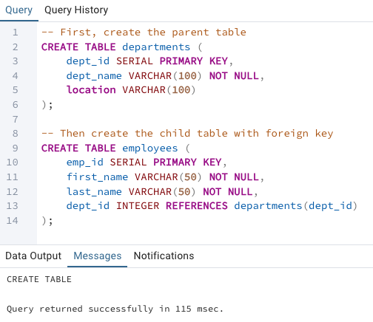

Method 2: Table-level constraint during creation
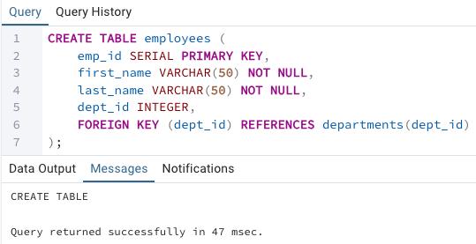

Method 3: Adding constraint to existing table
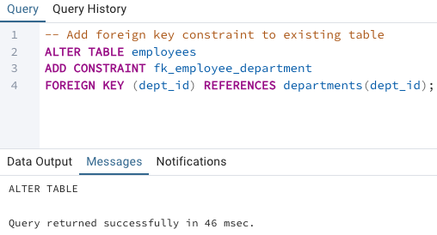

Method 4: Named constraint during table creation
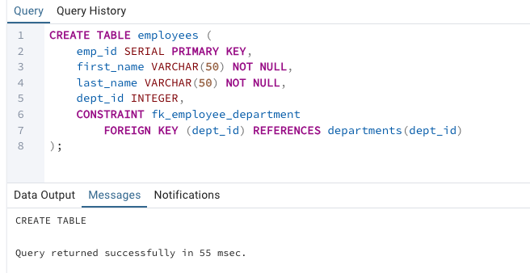

Referential integrity
Referential Integrity is a database concept that ensures relationships between tables remain consistent. When a foreign key is defined, the database automatically enforces rules to maintain data consistency.

Key principles of referential integrity:
- Insert Rule: You cannot insert a record with a foreign key value that doesn't exist in the referenced table
- Update Rule: You cannot update a foreign key to a value that doesn't exist in the referenced table
- Delete Rule: When you try to delete a record that is referenced by foreign keys, the database must handle this according to the specified CASCADE options
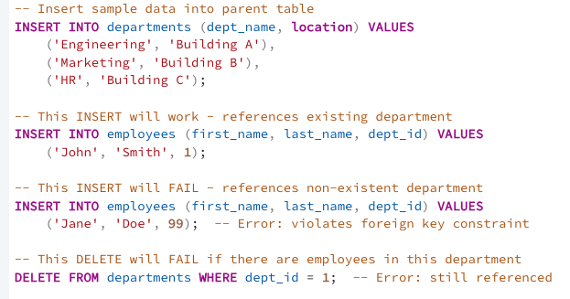

CASCADE options (ON DELETE, ON UPDATE)
CASCADE options define what happens when the referenced (parent) record is updated or deleted. PostgreSQL provides several options:

ON DELETE Options:
CASCADE - Automatically delete child records when parent is deleted
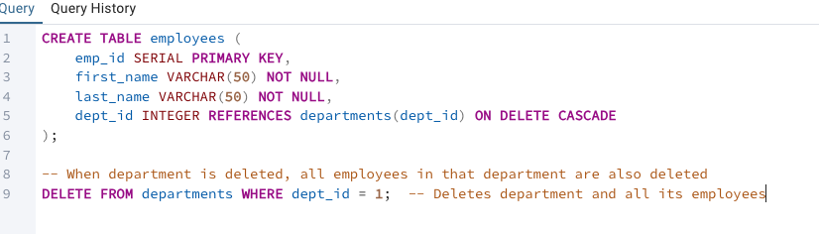
SET NULL - Set foreign key to NULL when parent is deleted
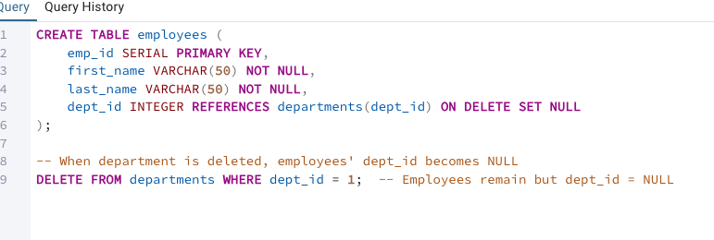

SET DEFAULT - Set foreign key to its default value when parent is deleted
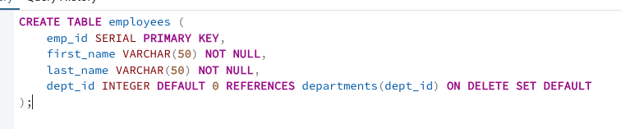

RESTRICT (default) - Prevent deletion of parent if child records exist
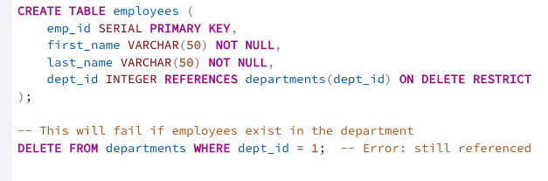

ON UPDATE Options:
CASCADE - Update foreign key values when parent key changes
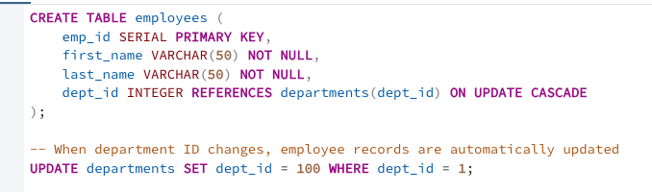

Combined CASCADE options:
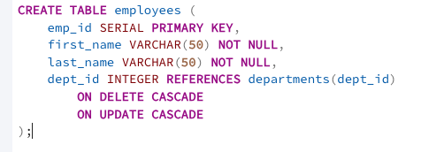

One-to-one relationships
A one-to-one relationship means that each record in Table A corresponds to exactly one record in Table B, and vice versa. This is implemented using a foreign key with a UNIQUE constraint.

Example:
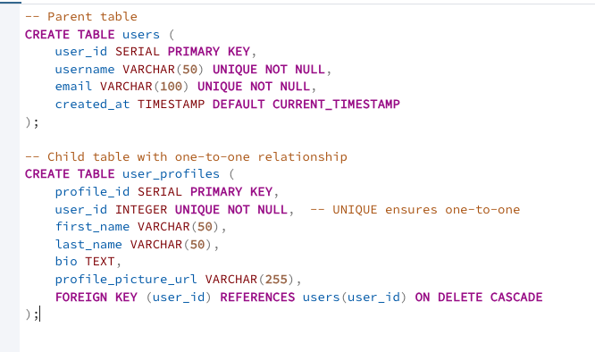

Alternative approach - sharing the same primary key:
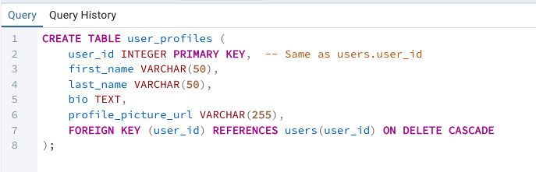
Example usage:
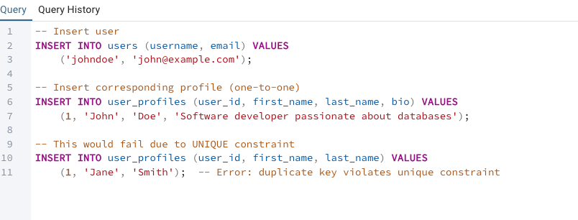

One-to-many relationships
A one-to-many relationship means that one record in Table A can correspond to multiple records in Table B, but each record in Table B corresponds to only one record in Table A. This is the most common type of relationship.

Examples:
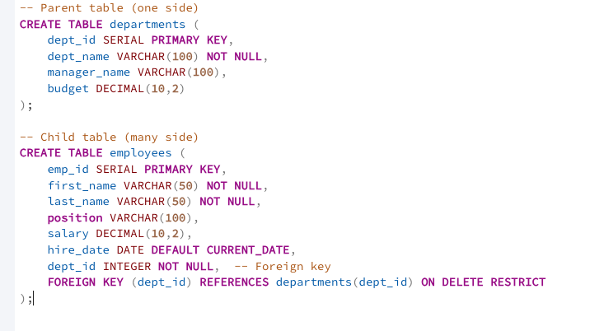
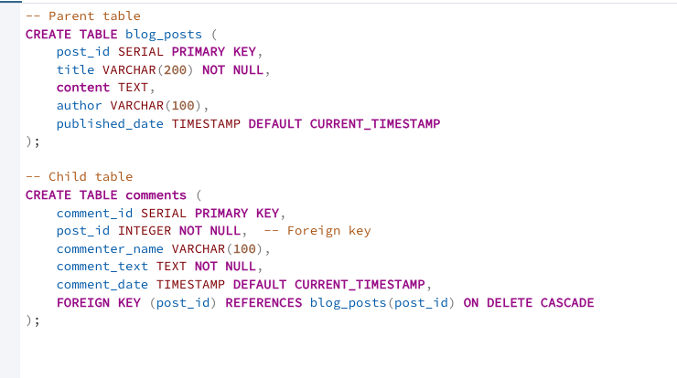

Example usage:
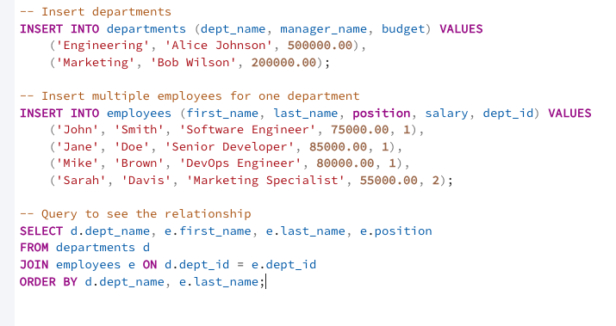

Many-to-many relationships
A many-to-many relationship means that multiple records in Table A can correspond to multiple records in Table B. This requires a junction table (also called a bridge table or associative table) that contains foreign keys referencing both tables.

Example:
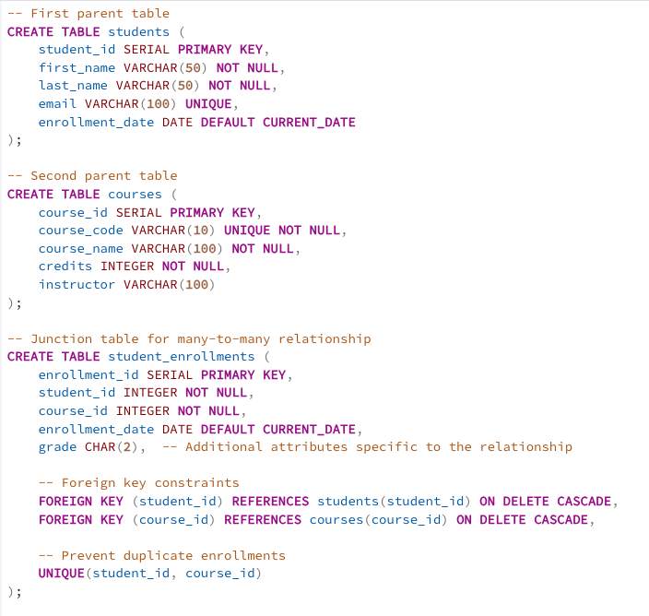

Example usage:
